
Assessment and Feedback: Student Template

Student ID Number(s): 2140890, 2869751, 2206997, 2307122, 2058902
Module: LM Business Analytics Capstone Project
Module Leader OR Dissertation/Extended Essay Supervisor: Dr Ambi Ambitunni and Dr Elvan Gokalp
Assignment Title: Project Report
Date and Time of Submission: 26/08/2025 at 13:10
Actual Word Count: 5000 words
Extension: N Extension Due Date: N/A
I do wish my anonymised assignment to be considered for including as an exemplar made available to UoB students.

Please ensure that you complete and attach this template to the front of all work that is submitted.
Declaration
By submitting your work, you are certifying that the submission is the result of your own work and does not contravene the University Code of Practice on Academic Integrity,. You must ensure that you have referred to valid sources of information to support your work, and that these are properly referenced in the required format (i.e. using Harvard referencing style).
If you have used a proofreader to review all or part of your work, you must declare this here:
☒ I have not used a proofreader
☐ I have used a proofreader. I confirm that the proofreader has not edited the text in an unacceptable manner as specified in Section A.1.6 of the Code of Practice on Academic Integrity² and School guidance.
If you have used Generative Artificial Intelligence (GenAI) to support the development of all or part of your work, you must declare this here:
☒ No content generated by GenAI tools has been used in the development of my final submission.
☐ I have used GenAI in the development of my final submission and confirm this has not been included as my own work. I have carefully checked and appropriately used the output according to the University’s guidance on using Generative Artificial Intelligence tools ethically for study and I take full responsibility of the entirety of the final submission. If this option has been selected, please retain your outputs as these could be requested by the module leader grading your work.

CONTINUED BELOW

The purpose of this template is to ensure you make the most effective use of your feedback that will support your learning. It is a requirement to complete both sections, and to include this completed template as the first page of every assignment that is submitted for marking (your School will advise on exceptions).
Section One: Reflecting on the feedback that I have received on previous assessments, the following issues/topics have been identified as areas for improvement: (add 3 bullet points). NB – for first year students/PGTs in the first term, this refers to assessments in your previous institution

- Structure
- Clarity
- Addressing the question

Section Two: In this assignment, I have attempted to act on previous feedback in the following ways (3 bullet points)

- We maintained a report structure throughout the report, making use of headings and subheadings to make it easier for the reader to follow
- We made use of tables and visuals to reaffirm the points made
- We based the structure off the project brief to stay close to client requirements

Measuring Spontaneous Awareness Growth for the NSPCC: How do we Measure it and Which KPI’s are Needed for the Campaign?

Executive Summary
Declining charitable giving in the UK has been accelerated by the COVID-19 pandemic and threatens child protection charities, with the NSPCC experiencing a 24% decline in spontaneous public awareness (2006–2024). This research moves beyond activity-based metrics to diagnose how awareness growth can be qualitatively measured for the NSPCC, and which key performance indicators (KPIs) best evaluate campaign impact on awareness and donation likelihood.
While prior studies establish links between awareness, trust, and donations, they rely on activity-based metrics and cross-sectional data, neglecting diagnostic analysis of donor motivations. To bridge this gap, we employ a mixed-methods approach integrating diagnostic text analysis of open-ended responses and predictive logistic regression using survey data from 86 respondents under the CRISP-DM framework.
Results identify moral alignment with the NSPCC’s mission and brand recognition as the strongest donation predictors, while non-donors cite lack of awareness and financial constraints as primary barriers. Demographically, older and married individuals show higher donation likelihood, with significant regional disparities. These findings inform five ethical brand strategies and six multidimensional KPIs, redefining measurement from quantitative reach to trust-weighted quality. This paradigm equips the NSPCC to achieve its 4-point awareness growth target by 2027 while aligning with its child protection mission.

Table of Contents
Executive Summary 4
Introduction 9
I. Background 9
II. Project Goal 9
Literature Review 11
I. Literature Trends 14
II. Current NSPCC Practices 15
III. Addressing Literature Gaps 16
IV. Conclusion 17
Methodology 18
I. Survey Design 18
II. Analytical Framework 19
Data Analysis 20
I. Data Understanding 20
II. Data Preparation 22
III. Data Models 23
IV. Text Analysis 27
Data Visualisations 29
Recommendations 31
I. Brand Strategy 31
II. Campaign Measurement Strategy 34
Conclusion 37
Appendices 39
Reference List 43

List of Figures
Figure 1: The Adapted CRISP-DM Framework (source: authors) 19
Figure 2: Corrected Participant Allocation (source: authors) 22
Figure 3: Non-donors who did not justify why they do not donate (source: authors) 22
Figure 4: Likert Logistic Regression Model (source: authors) 23
Figure 5: Correlation Matrix (source: authors) 24
Figure 6: Demographic Logistic Regression Model (source: authors) 25
Figure 7: Summary of motivators for donating to the NSPCC (source: authors) 28
Figure 8: Summary of motivators for not donating to the NSPCC (source: authors) 28
Figure 9: Dashboard 1 (source: authors) 29
Figure 10: Dashboard 2 (source: authors) 30
Figure 11: Dashboard 3 (source: authors) 31

List of Tables
Table 1: Summary thematic analysis of 30 relevant studies (source: authors) 12
Table 2: Overview of Features (source: authors) 20
Table 3: Descriptive Statistics of Survey Question (source: authors) 21
Table 4: Mean Scores by Donation Status (source: authors) 21
Table 5: Logistic model results and Confusion Matrix (source: authors) 24
Table 6: Feature effects on Donation Likelihood (source: authors) 25
Table 7: Logistic model results and Confusion Matrix (source: authors) 26
Table 8: Recommended Tailored Brand Strategy (source: authors) 32
Table 9: Recommended Tailored Campaign Measurement Strategy (source: authors) 35

List of Appendices

Appendix A: Project Brief from James Barker, Head of Marketing at NSPCC……….……39
Appendix B: Survey Section 1………………………………………………………………40
Appendix C: Survey Section 2 for Donors…………………………………………………..41
Appendix D: Survey Section 2 for Non-Donors……………………………………………..42
Appendix E: Link to Interactive Story……………………………...………………………..42

Introduction

Background
In the UK, the aftermath of the Covid-19 pandemic has seen a significant decline in charitable giving, with an estimated four million fewer donors, attributed to tightened household budgets and waning interest among younger demographics, particularly those aged 16-24 (Peachey, 2025). This decline has intensified existing concerns around public trust, confidence, and support, critical components of a charity’s legitimacy and long-term viability (Hyndman and McConville, 2018).

Within the UK, the National Society for the Prevention of Cruelty to Children (NSPCC) is the leading children’s charity, uniquely holding statutory powers to intervene in child abuse cases (NSPCC, 2025). Yet, like much of the sector, they are facing increased pressures: the NSPCC’s biannual brand tracker revealed a 24-percentage-point drop in public awareness between 2006 and 2024, contributing to reduced public knowledge, financial support, and staff retention (Appendix A). In response, the NSPCC aims to increase its spontaneous awareness by 4 percentage points by 2027 (Appendix A). Enhancing visibility is critical, as greater public awareness is strongly linked to increased charitable support and fundraising outcomes (Bourassa and Stang, 2015; Sisco and McCorkindale, 2013).

While business analytics provides tools for analysis, its non-profit application is often limited to descriptive segmentation (Appenidix A). This project extends its use to a diagnostic and predictive framework, enabling strategic decisions that target the root causes of awareness decline to strengthen the NSPCC's brand presence.

Project Goal
Stanley (2017) argues the NSPCC’s current analytical approach is superficial, as it primarily focuses on descriptive analytics, identifying who is interacting with the organisation, while neglecting the question of why individuals choose to engage or donate. The lack of insight into donor motivations represents a significant gap in understanding, potentially limiting the effectiveness of fundraising strategies. In response, this report seeks to address this gap by exploring the underlying motivations driving donor behaviour through diagnostic, predictive and prescriptive analysis. Diagnostic analysis is performed using text analysis to understand the underlying motivations for donation likelihood. Predictive analysis is performed using logistic regression models to predict the probability of donation likelihood based on individual characteristics. Finally, prescriptive analysis informs the brand strategy and campaign measurement strategy found in the report's discussion. By gaining a deeper understanding of the psychology, emotional, and situational factors that influence donations, the findings aim to inform a more targeted marketing strategy to bolster the NSPCC’s fundraising strategies. Hence, the research aims to address the following questions:

RQ1: How can the NSPCC effectively measure spontaneous awareness growth?
RQ2: What key performance indicators (KPIs) are most relevant for evaluating a campaign’s impact on public awareness and the likelihood of donation?

Crucially, this report adopts an ethical lens throughout its design and execution, recognising the moral responsibility inherent in working with a charity dedicated to child protection. Ethical consideration will inform the treatment of participant consent and the broader context underpinning the research. By contextualising the strategy within a framework of ethical marketing and social responsibility, this report aims to align measurement practices with the NSPCC’s values-driven mission and public accountability.

The report continues with a literature review examining key concepts and variables in campaign measurement, followed by a methodology outlining the mixed methods design and analytical framework. This is succeeded by data analysis and visualisation for interpretive clarity. The discussion then proposes a targeted brand and campaign measurement strategy, before concluding with limitations, biases, and directions for future research

Literature Review
This literature review examines evidence-based approaches to measuring awareness growth and identifies critical KPIs that drive both increased awareness and higher donation likelihood, addressing NSPCC objectives. Table 1 presents a summary thematic analysis of the 30 selected studies informing this review.

Table 1: Summary thematic analysis of 30 relevant studies (source: authors)
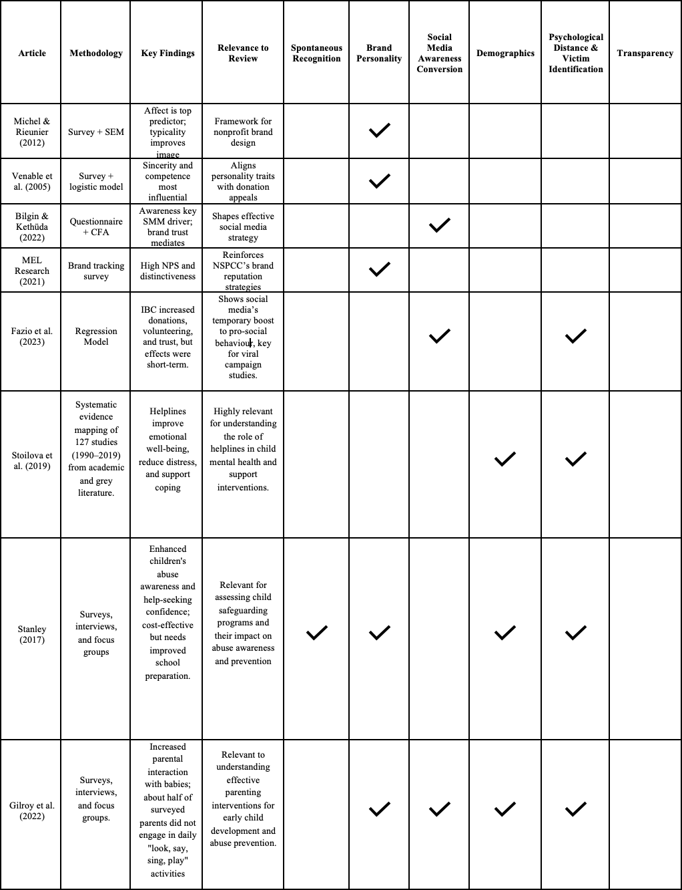
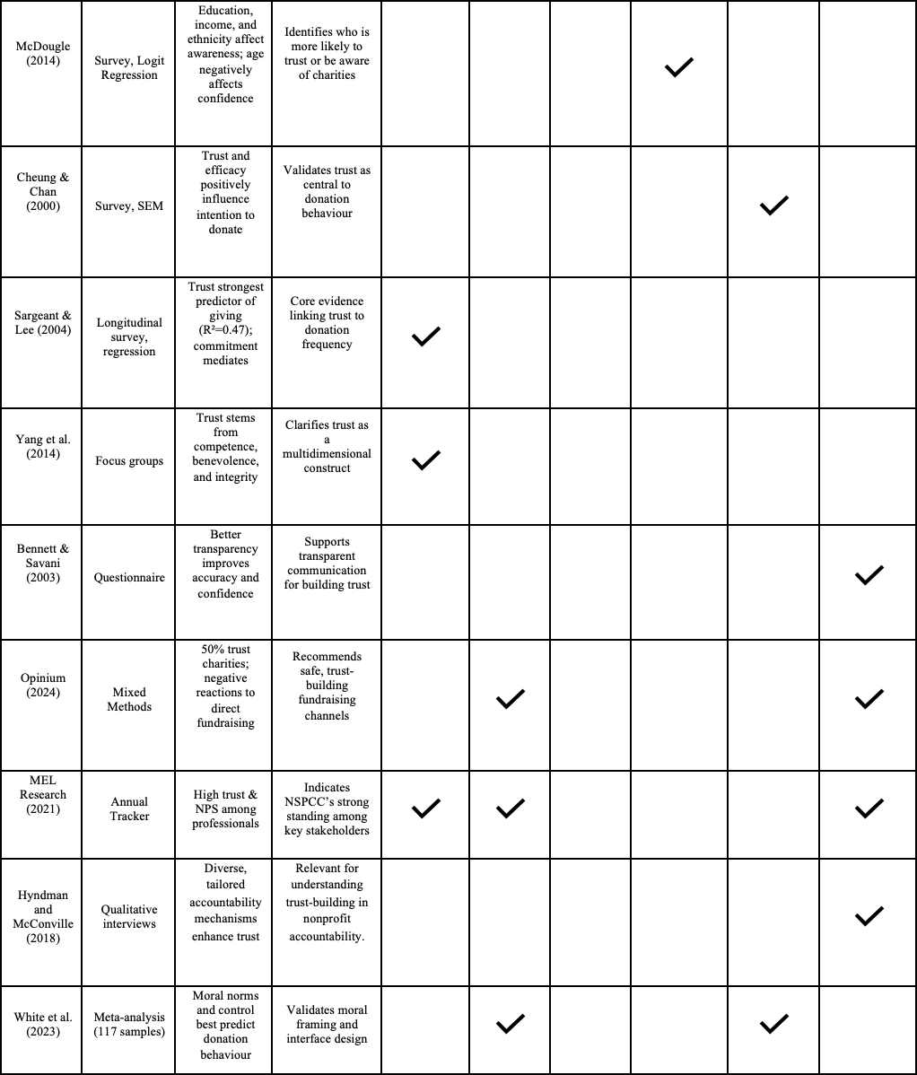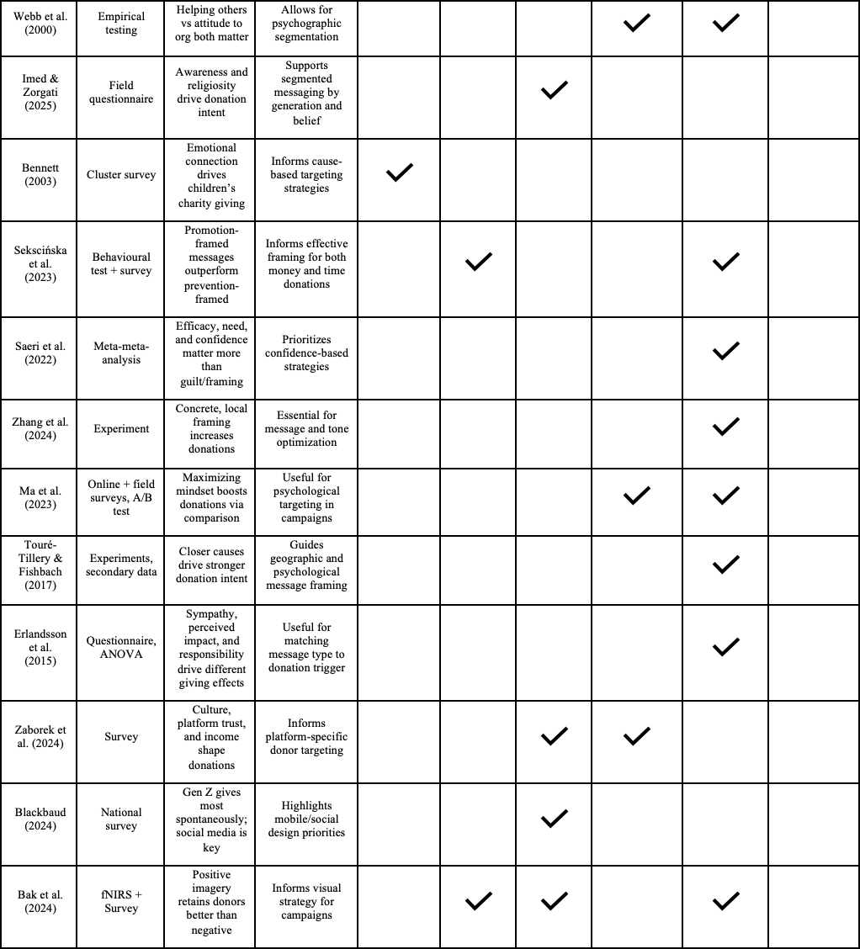

Literature Trends
The literature demonstrates a shift from basic demographic awareness to psychological and emotional frameworks for understanding donation behaviour. Cheung and Chan (2000) identified key predictors, including self-efficacy, trust, moral obligation, perceived need, awareness, and past giving. Webb et al. (2000) distinguished attitudes toward helping others (AHO) from attitudes toward charitable organisations (ACO), both influencing charitable behaviour.
Furthermore, brand personality and emotional factors shape donation behaviour. Venable et al. (2005) highlighted sincerity and competence as primary drivers, while Michel and Rieunier (2012) found brand image explains 31% of donation intentions, with effect dimension most predictive. Trust consistently mediates awareness and donation behaviour through relationship commitment: Sargeant and Lee (2004) identified trust as the strongest predictor, and Yang, Brennan, and Wilkinson (2014) outlined competence, benevolence, and integrity as key trust dimensions. Transparency also enhances trust and awareness (Bennett & Savani, 2003).
Recent research emphasises digital and generational strategies. Bilgin and Kethüda (2022) show awareness as the critical social media KPI, moreover, Fazio et al. (2023) note social media’s short-term effect on awareness, and Imed and Zorgati (2025) highlight the need for generationally tailored campaigns using innovative approaches.

Current NSPCC Practices
Current NSPCC measurement practices demonstrate somewhat sophisticated approaches. They conduct annual brand tracking of approximately 800 safeguarding professionals, measuring NSPCC awareness, reputation, distinctiveness, and advocacy through Net Promoter Scores, with high scores suggesting strong potential for donations (M·E·L Research, 2021).
However, Stanley (2017) identified limitations in NSPCC's current approach through qualitative insights, noting that while the organisation sets dozens of measurable targets including reaching 5 million children and achieving 50% increases in helpline calls, many metrics remain activity-based rather than impact-focused. This emphasis on output over outcome risks focusing on reach rather than meaningful change. Gilroy et al. (2022) reinforces this concern in their mixed-methods evaluation of the NSPCC’s "Look, Say, Sing, Play" campaign, revealing while parents reported greater interaction, roughly half did not carry out activities daily, suggesting only partial behavioural uptake. Together, these findings suggest a deeper methodology change is required, prioritising long-term behavioural outcomes to improve NSPCC campaign success.

III. Addressing Literature Gaps
Despite their importance, non-economic metrics are often overlooked by charitable organisations, which tend to prioritise financial and efficiency measures (Yang et al., 2014; Campos et al., 2011). However, this short-sightedness fails to consider the broader purpose of charities, which is to promote societal improvement and meaningful change (Ebrahim, 2005). As such, incorporating non-economic KPI’s are essential to accurately assess a charity’s true performance and areas for growth.

The following emerges as primary KPI’s for NSPCC concern:
Spontaneous Recognition: Combining Bennett and Savani’s (2003) sector-specific benchmark of 34% spontaneous awareness for children's charities with Yang, Brennan and Wilkinson's (2014) three-dimensional trust framework, NSPCC should measure unaided brand recognition weighted by competence, benevolence, and integrity perceptions. This composite metric addresses Sargeant and Lee's (2004) finding that trust (R² = 0.47) predicts donation behaviour more strongly than awareness alone (23% correlation).
Brand Personality: Based on Venable et al.'s (2005) research showing sincerity and competence as most important for children's charities, NSPCC should measure these specific personality dimensions as awareness quality indicators. Michel and Rieunier's (2012) finding that affect dimension most strongly predicts donation behaviour reinforces the need to measure emotional connection alongside brand recognition.
Social Media Conversion: Following Bilgin and Kethüda's (2022) confirmatory factor analysis showing awareness as the only social media dimension significantly influencing donation intention, NSPCC should track digital awareness effectiveness across generational segments, incorporating Imed and Zorgati's (2025) findings about generation-specific messaging requirements.
Demographics: McDougle (2014) established that educational attainment positively correlates with nonprofit awareness while higher income groups demonstrate 16% greater awareness levels. NSPCC should track penetration across these segments, with particular attention to college graduates and married individuals who show greater confidence in nonprofit service provision.

Psychological Distance: Touré-Tillery and Fishbach (2017) demonstrated that individuals expect donations to have greater impact on nearby recipients, increasing willingness to donate. Erlandsson, Björklund and Bäckström (2015) showed that identifiable victim effect is mediated by emotional reactions while proportion dominance effect operates through perceived impact. NSPCC should measure geographical and psychological proximity in awareness campaigns.
Transparency: Bennett and Savani (2003) demonstrated that small amounts of useful information about charity performance improve public judgment accuracy. Hyndman and McConville (2018) argued for stakeholder involvement in measuring performance through user-satisfaction surveys, emphasising that transparency regarding effectiveness is critical to stakeholder engagement. Therefore, the NSPCC should leverage greater transparency by incorporating clearer performance reporting and stakeholder-driven feedback into its campaigns, ensuring accountability while strengthening public trust and donation intent.

IV. Conclusion
Overall, this research will directly address the identified gaps within the literature by integrating non-economic performance measures into a more holistic evaluation framework. Hence, moving beyond current superficial indicators to capture the broader dimensions of trust, awareness quality, emotional connection, demographic reach, psychological distance, and transparency. As a set framework has not been established within current literature, these findings will provide the foundation for developing a strategic brand and campaign strategy framework tailored to the NSPCC, to strengthen its brand positioning, enhance stakeholder trust, and ultimately increase awareness and donation likelihood.

Methodology

I. Survey Design
This study employs a mixed-methods research design using primary data collected via survey. The survey included both quantitative 7-point Likert scale items and qualitative open-ended responses (Appendix B–D). A mixed-methods approach is particularly appropriate as it integrates measurable trends with public insights, addressing the complex and multifaceted nature of spontaneous awareness and donor engagement. This provides a balanced, multidimensional understanding, critical for developing targeted and effective future NSPCC campaigns (Coyle and Williams, 2000; Morse and Chung, 2003). This combination enhances the validity and depth of the findings by allowing one method to inform and strengthen the other (Hurmerinta-Peltomaki and Nummela, 2006; O’Cathain et al., 2007).

To recruit participants, a network sampling approach was adopted, leveraging existing personal and professional networks. This method was selected due to practical constraints such as time and resource limitations, alongside the inherent difficulty of reaching a representative sample of donors and non-donors through randomised techniques (Atkinson and Flint, 2001). Network sampling also increased the likelihood of diversity across demographic groups, ensuring the required variation for analysing donation likelihood. While this approach introduces the risk of sample homogeneity and reduced generalisability, the pragmatic trade-off was deemed acceptable for an exploratory project of this scope. Furthermore, efforts were made to mitigate potential bias by circulating the survey across different network groups, broadening the reach and enhancing respondent diversity.

Participants were provided with a clear statement ensuring the anonymity of their responses, with assurances that their information would remain confidential and be used exclusively for internal research purposes (Appendix B). This emphasis on transparency and consent aligns with the wider ethical responsibility of conducting research on charitable giving, ensuring that participants’ rights and privacy were safeguarded.

II. Analytical Framework
This study follows the Cross-Industry Standard Process for Data Mining, CRISP-DM, a widely used framework in industry and academia. CRISP-DM was selected due to its robustness as it integrates key principles from Knowledge Discovery and SEMMA, emphasising both the business context and technical data processes (Martínez-Plumed et al., 2019). Therefore, providing an appropriate framework to guide this analytical project for the NSPCC. Figure 1 illustrates the adoption of CRISP-DM within the report.
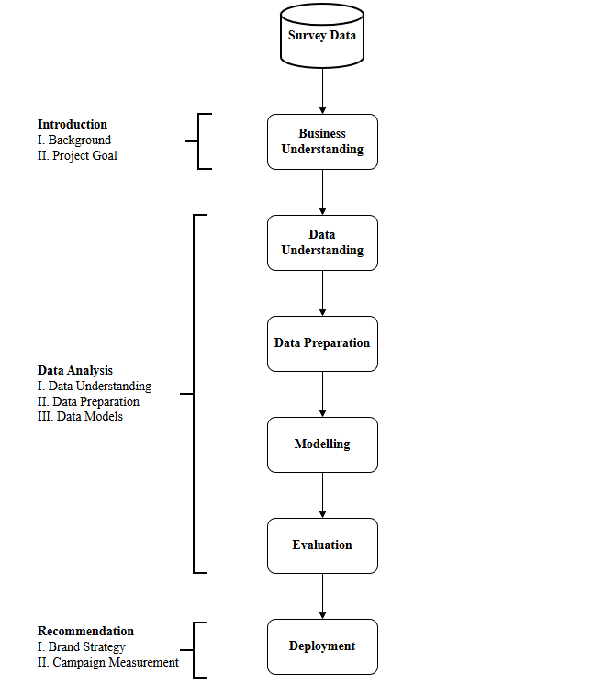
Figure 1: The Adapted CRISP-DM Framework (source: authors)

Data Analysis

I. Data Understanding
The dataset includes 86 survey respondents, capturing open-ended, demographic, and behavioural indicators related to donation likelihood. The target variable is binary: 29 donors (24.9%) and 57 non-donors (49%). Table 2 summarises features by data level and type.
Table 2: Overview of Features (source: authors)
Feature | Data Level | Data Type | Time | Structure
Education Level | Categorical | Qualitative | Cross-sectional | Structured
Age Bracket | Ordinal | Qualitative | Cross-sectional | Structured
Marital Status | Categorical | Qualitative | Cross-sectional | Structured
Region | Categorical | Qualitative | Cross-sectional | Structured
Donation | Binomial | Quantitative | Cross-sectional | Structured
Survey questions | Ordinal | Quantitative | Cross-sectional | Structured

Education Level, Marital Status, and Region are categorical qualitative variables with no inherent order. Age Bracket is ordinal qualitative: “18–24”, “25–34”, “35–44”, “45–54”, “55–64”, “65+”. Donation is binomial quantitative (1 = donor, 0 = non-donor). Survey questions used Likert scales for ordinal quantitative comparisons.

The survey included the following four questions measuring respondents’ agreement with statements about the NSPCC:

Q1: “I know where my donations to the NSPCC are going.”
Q2: “The NSPCC’s campaigns align with my morals.”
Q3: “When I think of a child protection charity, the NSPCC comes top of mind.”
Q4: “It is important to me that the NSPCC helps children in my region.”

Table 3: Descriptive Statistics of Survey Question (source: authors)
 | Donation | Q1 | Q2 | Q3 | Q4
Count | 86 | 86 | 86 | 86 | 86
Mean | 0.3452 | 4.238 | 5.4404 | 4.7619 | 5.7857
Std | 0.4783 | 1.8796 | 1.4087 | 1.8860 | 1.4318
Min | 0 | 1 | 1 | 1 | 1
25% | 0 | 3 | 4 | 4 | 5
50% | 0 | 4 | 6 | 5 | 6
75% | 1 | 6 | 7 | 7 | 7
Max | 1 | 7 | 7 | 7 | 7

Table 3 shows moderate-to-high agreement with the Likert-scale statements, with mean scores ranging from 4.24 (lowest for donation knowledge, Q1) to 5.79 (highest for regional importance, Q4). Respondents most strongly agreed with Q2 (moral alignment, mean = 5.44).

Distributions reveal the max ceiling as 7 and the medians at or above 4, a positive skew toward higher scores. Standard deviations indicate greater variation in responses for Q1 (SD = 1.88) and Q3 (SD = 1.89) compared to Q4 (SD = 1.43), suggesting more consensus around the importance of regional impact.

Table 4: Mean Scores by Donation Status (source: authors)
Question | Donors | Non-donors | Difference
Q1 | 4.79 | 3.95 | 0.85
Q2 | 6.24 | 5.02 | 1.22
Q3 | 5.66 | 4.29 | 1.36
Q4 | 6.03 | 5.65 | 0.38

Table 4 reveals donors consistently scored higher than non-donors across all four questions, The largest differences are observed in Q3 (+1.36) and Q2 (+1.22), implying stronger alignment of donors with NSPCC’s mission and brand recognition.

II. Data Preparation
Quantitative Data
Python was selected for logistic regression implementation due to its robust statistical libraries, such as scikit-learn, statsmodels, and pandas, enabling successful model development.
No missing values were detected in either the target or predictor variables when checking with the .isnull().sum() pandas’ function. Duplicates were scanned and removed using unique respondent identifiers by cross-verifying against survey guidelines. The Likert-scale question responses were numerically coded to enable statistical analysis. Each response option was assigned a numeric value, allowing the data to be treated as ordinal to support the descriptive statistics, correlations, and predictive modelling.
Vrigazova (2021) suggests the best models have 70-80% of data for training and 20-30% for testing, therefore, the dataset was split into training (70%) and test (30%) subsets using stratified sampling to preserve the proportion of donors and non-donors. This ensured robust model evaluation while being flexible to class imbalance.
Qualitative Data
Survey data was exported to an Excel dataset, filtered by donor status, and allocated into distinct datasets. To simplify the analysis, column names were aliased, such as “What is your marital status?” which became “Marital Status.” As Singh et al. (2021) propose, checks were made to identify and address data deemed as 'noise' or inconsistent, which, in turn, would ensure accurate results. For instance, a single, 18–24-year-old master's student from the West Midlands answered “yes” to Question 5 (Appendix C). However, their data was transferred to the non-donors' dataset since they do not donate to the NSPCC (Figure 2).
Figure 2: Corrected Participant Allocation (source: authors)
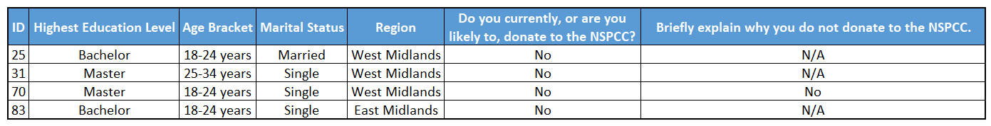
Figure 3: Non-donors who did not justify why they do not donate (source: authors)
Four participants were included only in the quantitative counts of non-donors but excluded from the content analysis as they did not provide any text to analyse (Figure 3).

III. Data Models
Model 1: Likert Logistic Regression Model
A logistic regression model was coded to predict the donation likelihood based on an individual's response to Q1–Q4. This model can serve as a predictive tool, determining the key predictors to donation likelihood. The model is specified as:
$ln(\frac{p}{1 - p}) = β_{0}+β_{1}* Q1 + β_{2}* Q2 + β_{3}* Q3 + β_{4}* Q4 + εᵢ$
where p represents donation probability.

Figure 4: Likert Logistic Regression Model (source: authors)

Each coefficient directly represents the change in the log-odds of donation for a one-unit change in each survey question score.
Due to its linear parameters, the model has lower model capacity (expressiveness) than highly flexible models like random forests or neural networks (Bulso, Marsili and Roudi, 2019). Lower capacity reduces the likelihood of fitting noise in small datasets and thereby helps control overfitting. To address class imbalance, the logistic regression was configured with class_weight='balanced', which increases the weight of errors on the minority class. Ensuring the model’s effectiveness in detecting potential donors.
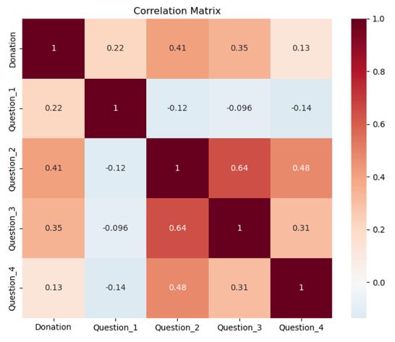
Figure 5: Correlation Matrix (source: authors)
The correlation matrix in Figure 5 showed no excessively high inter‑correlations, suggesting that problematic multicollinearity is unlikely to be present. This supports the logistic regression assumption that predictors are not highly collinear (Stoltzfus, 2011). Alongside the assumption of independence of errors, meeting this condition reinforces the appropriateness of applying logistic regression in this study.

Table 5: Logistic model results and Confusion Matrix (source: authors)
   | Precision | Recall | F1-score | support
  0 | 0.76 | 0.94 | 0.84 | 17
  1 | 0.80 | 0.44 | 0.57 | 9
  Accuracy |  |  | 0.77 | 26
  Macro average | 0.78 | 0.69 | 0.71 | 26
  Weighted average | 0.78 | 0.77 | 0.75 | 26
  Predicted | 0 | 1
  Actual 0 | 16 | 1
  Actual 1 | 5 | 4

Table 5 shows the logistic regression model achieved a test set accuracy of 76.9% with an ROC AUC of 0.804 demonstrating good contrast between donors and non-donors. Furthermore, the model is strong at identifying non-donors (recall = 0.94, F1 = 0.84), though performs poorly for donors (recall = 0.44, F1 = 0.57). Precision for donors is acceptable (0.80). However, it exhibits a notable limitation in recall, failing to detect more than half of the actual donor cases (0.44), which suggests a significant under-identification of true positives. To improve the model, collecting more donor samples to balance the dataset would reduce model bias toward predicting non-donors. Additionally, Mitani et al. (2024) suggests applying class weights can provide negligible bias to the model.

Table 6: Feature effects on Donation Likelihood (source: authors)
Question | Coefficient | Odds Ratio | Statistical Significance (2-sample t-test)
Q1 | 0.654 | 1.923 | p = 0.0488 (*), weaker correlation (r = 0.216) but still significant.
Q2 | 1.181 | 3.257 | p = 0.0001 (***), largest effect and strongest correlation (r = 0.415)
Q3 | 0.202 | 1.224 | p = 0.0013 (**), moderate correlation (r = 0.346)
Q4 | -0.399 | 0.671 | p = 0.2499 (ns), no significant association

From results in Table 6, the dominance of Q2 (moral alignment) as the primary predictor,
exhibiting a p-value of 0.0001 (< 0.05), extends the work of Venable et al. (2005). While they
identified ‘sincerity’ as a key brand personality trait, our finding places a higher importance
donor's perception of having shared moral values. Furthermore, Q3 (brand identity) and Q1
(transparency) demonstrates moderate statistical significance. However, Q4’s negative
coefficient and non-significance (p = 0.2499), indicates limited predictive power due to
overfitting.

Model 2: Demographic Logistic Model
This study employs binary logistic regression to examine demographic predictors of charitable donation behaviour using a dataset of 86 observations. The model is specified as:
$$ln\left(\frac{p}{1 - p}\right)=β_{0}+β_{1}*\left(Education\right)+β_{2}*\left(Age\right)+β_{3}*\left(MaritalStatus\right)+β_{4}*\left(Region\right)+εᵢ$$
where p represents donation probability.

Figure 6: Demographic Logistic Regression Model (source: authors)
Reference categories were established using dummy coding: Bachelor's degree (education baseline as middle-ground qualification), 18-24 years (youngest age cohort for lifecycle comparison), Single (most common marital status) and East Midlands (alphabetically selected regional baseline).
The logistic specification addresses the bounded nature of probability (0-1) while avoiding heteroskedasticity present in linear probability models (Long, 1997). The non-linear relationship between demographic predictors and donation probability further necessitates the logistic transformation (Andreoni, 2006). Extensive empirical evidence supports logistic modelling in charitable giving research. Schlegelmilch et al. (1997) demonstrated the model’s effectiveness in examining socio-demographic predictors of European donation behaviour, while Pharoah and Tanner (1997) used binary choice models for UK philanthropy analysis. The approach aligns with Bekkers and Wiepking’s (2011) comprehensive review identifying demographic characteristics as fundamental donation determinants, supporting the inclusion of education, age, marital status, and regional variables as key predictors.
The sample exhibited a 37.8% donation rate with substantial demographic variation. Education-wise, HND holders showed the highest donation rate (100%), followed by PhD (75%) and HNC (50%). Age analysis revealed significant variation across different age cohorts: 35-44 years (100% donation rate), 55-64 years (88.9%), contrasting sharply with younger cohorts (18-24 years: 24.3%). Married individuals demonstrated higher donation propensity (58.3%) compared to single participants (28.1%).
Table 7: Logistic model results and Confusion Matrix (source: authors)
   | Precision | Recall | F1-score | support
  0 | 0.75 | 0.94 | 0.83 | 16
  1 | 0.80 | 0.44 | 0.57 | 9
  Accuracy |  |  | 0.76 | 25
  Macro average | 0.78 | 0.69 | 0.70 | 25
  Weighted average | 0.77 | 0.76 | 0.75 | 25
  Predicted | 0 | 1
  Actual 0 | 15 | 1
  Actual 1 | 5 | 4
Table 7 shows the logistic regression achieved strong predictive accuracy with AUC = 0.778, indicating good identification power. Cross-validation with a 70:30 split resulted in 76% accuracy, with precision of 80% for donation prediction.
Coefficient analysis reveals significant demographic effects on donation likelihood. Age demonstrates the strongest predictive power, with 55-64 years showing the highest positive coefficient (1.22), indicating 238% higher odds versus the 18-24 reference category. The 35-44 cohort exhibits perfect separation effects. Education coefficients show PhD holders with substantial positive effects (coefficient: -0.180 relative to Bachelor's), while Master's degree holders demonstrate moderate positive association (coefficient: 0.265). Regional analysis indicates East of England as having negative predictive power (coefficient: -0.722), suggesting 51% lower donation odds compared to East Midlands baseline. Marital status reveals married individuals with strong positive coefficients (0.139), indicating 15% increased odds versus single status. The confusion matrix demonstrates good specificity (93.8%) with moderate sensitivity (44.4%), reflecting conservative prediction.

IV. Text Analysis
To capture donor motivations without the constraints of predefined categories, participants provided open responses, enabling themes to be derived (Hammad et al., 2016). These responses were examined through text analysis to identify recurring patterns (Shumate et al., 2013).

Figure 7 reveals donor motivations are primarily emotional, with recurring terms such as “support,” “protect,” and “safe.” In contrast, non-donors emphasise barriers including limited awareness, financial constraints, and uncertainty about the NSPCC’s practices, frequently citing “unaware,” “afford,” and “unsure.” Notably, non-donor responses generated more distinct themes (11) than donor responses (8), indicating that barriers to giving are more diverse than motivators. This supports the need for a long-term strategy focused on both attracting and sustaining donor commitment.

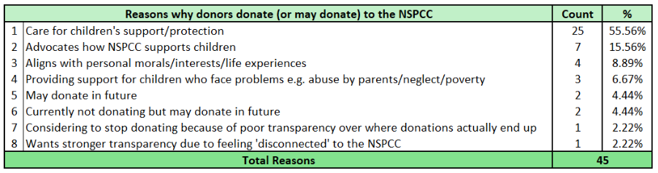
Figure 7: Summary of motivators for donating to the NSPCC (source: authors)

Over half (56%) of NSPCC donors or prospects are intrinsically motivated to improve children’s lives, while 9% are non-donors who express potential future giving (Figure 7).

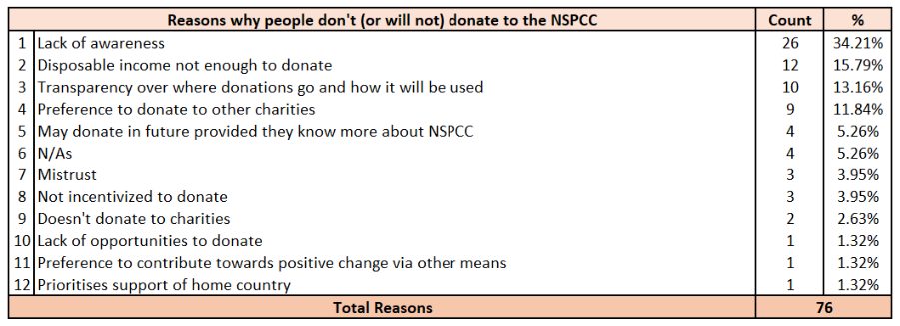
Figure 8: Summary of motivators for not donating to the NSPCC (source: authors)

The NSPCC should strengthen transparency, particularly in showing how donations directly support children, as 4% of current donors are considering withdrawal for this reason (Figure 8). Among non-donors, the main barriers are limited awareness of NSPCC’s activities, uncertainty over donation allocation, and financial constraints affecting 50%. These challenges also intersect with donor priorities, with 12% favouring other charities. Without clearer communication and accountability, the NSPCC risks both donor attrition and missed opportunities for acquisition.

Data Visualisations
In line with the project’s objective to diagnose the factors underlying the NSPCC’s decline in spontaneous awareness, the integrated Tableau dashboards synthesise the survey data into a strategic diagnostic tool (the link to the interactive story is provided in Appendix E). This approach transforms raw data into a coherent narrative by combining donor and non-donor datasets, standardising demographic and attitudinal scales, and coding open-text responses into quantifiable categories. The resulting analysis offers a triangulated perspective across three dimensions: audience composition, attitudinal drivers, and motivational reasons, providing a holistic view of public engagement.

The first dashboard profiles the respondent audience (Figure 9). A key finding is the positive association between higher educational attainment and donor status. This aligns with McDougle (2014), who found that awareness of nonprofit organisations varies significantly by individual-level characteristics, including education, thereby supporting the link between higher attainment and greater engagement. The analysis further reveals pronounced regional clustering of donations, indicating significant geographic disparities in campaign effectiveness and brand penetration that necessitate targeted localised strategies.

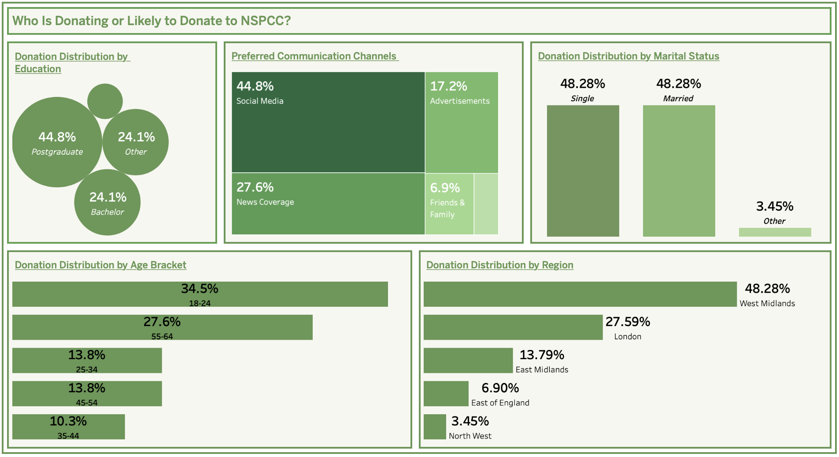
Figure 9: Dashboard 1 (source: authors)
The second dashboard contrasts donors and non-donors across key attitudinal factors (Figure 10). Donors report stronger agreement on brand awareness and moral alignment with the NSPCC’s mission, while non-donors remain largely neutral, especially regarding trust and spontaneous recall. This neutrality signals a persuadable segment defined by indifference rather than opposition. This finding supports Sargeant and Lee (2004) showing trust is central to donor behaviour, and its absence represents a barrier that can be overcome through targeted communication strategies.

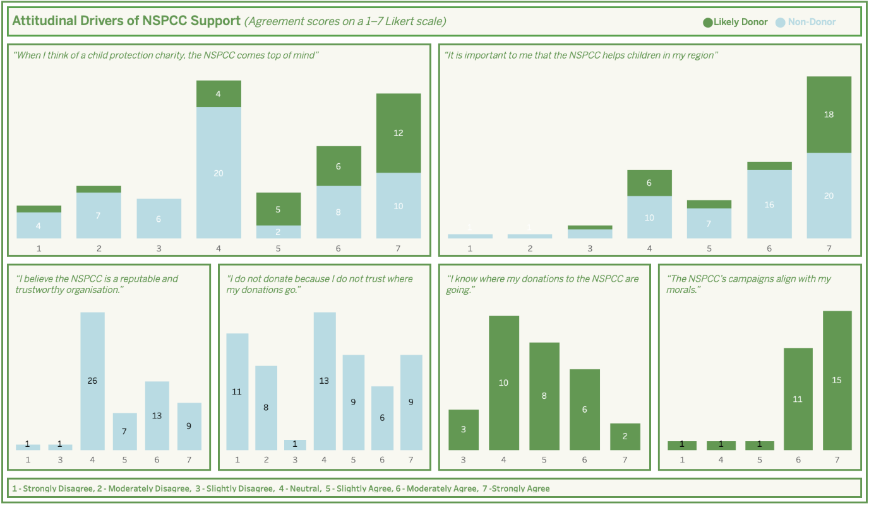
Figure 10: Dashboard 2 (source: authors)

The third dashboard visualises the coded open-text responses through a heatmap, cross-referenced by age group (Figure 11). This analysis identifies the fundamental drivers and barriers to donation. The primary motivator for donors is a fundamental concern for children’s welfare and protection. Conversely, the most significant barrier among non-donors is simply lack of awareness of the NSPCC’s work and impact, followed by financial constraints. This finding reinforces Bekkers and Wiepking (2011), which identifies 'awareness of need' as a key driver to charitable giving.
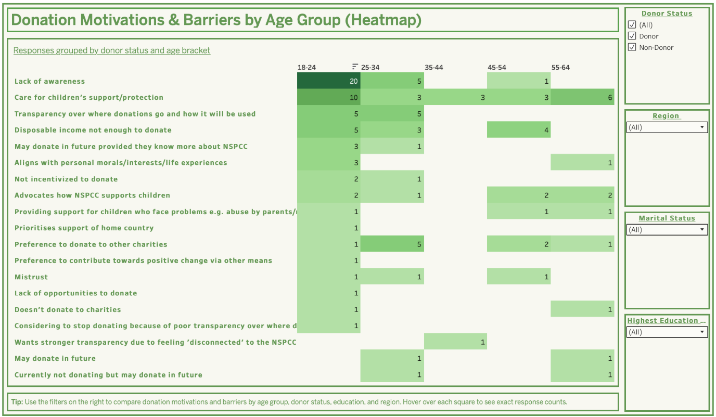
Figure 11: Dashboard 3 (source: authors)

In conclusion, the dashboards move beyond descriptive statistics to provide actionable strategic insights. They clearly identify who to prioritise (demographic and geographic segments), what to communicate (transparency, impact, and value alignment), and where to focus campaign efforts. This diagnostic approach directly enables the data-driven brand strategy and KPI framework required to reverse the NSPCC’s awareness decline.

Recommendations

Brand Strategy
The diagnostic and predictive analyses conducted in this study reveal clear patterns in donation behaviour, offering a data-driven foundation for refining the NSPCC’s brand strategy. The logistic regression models identified key demographic and regional predictors of donation likelihood, while text analysis uncovered the donor motivations driving decision-making.

Table 8 translates these insights into five targeted brand strategy recommendations, designed to be actionable, measurable, and ethically aligned with the NSPCC’s mission. The proposed recommendations blend visibility strategies (raising awareness in underperforming regions), messaging strategies (clarity of impact and transparency), and engagement strategies (peer storytelling, youth-targeted campaigns). Each recommendation includes tailored KPIs to support evaluation, ensuring alignment with the organisation’s need for robust campaign measurement. Furthermore, this approach strengthens the brand’s image with existing supporters and actively cultivates new donors, particularly those who may have the motivation to give but lack the necessary awareness or trust to act.

Table 8: Recommended Tailored Brand Strategy (source: authors)
Recommendation | Rationale | Implementation Approach | KPIs | Expected Impact | Ethical Considerations
“Your Local NSPCC”  Regional campaigns to boost the visibility of regional hubs | 48% of respondents strongly agree it is important the NSPCC helps children in their region; lack of awareness is a major barrier to donations | Geo-targeted ads, local press features, hub open days, partnerships with schools and councils, online hub presence with stories of local impact | Regional awareness scores, local web traffic, event attendance, regional donations | Strengthen community connection and trust, converting awareness into action | Ensure inclusive representation of local communities, avoid framing other regions as less important
“Show Me the Impact”  Nation-wide transparency campaign | Non-donors have neutral trust and uncertainty about use of funds, presents a barrier to donation | Create a dynamic “Where Your £5 Goes” tracker on the website, include impact statistics in every campaign, post quarterly donor reports on website | Trust score, donation conversion rate | Remove hesitation barrier and boost donation confidence | Keep figures accurate and contextual, avoid oversimplifying complex work
“Youth Connector”  Engage 18-24 age group | Logistic regression model shows 18-24 years have the lowest donation rate (24.3%), low trust and awareness was identified for this group | Collaborate with youth influencers, use TikTok/ Instagram Reels to share peer-led stories, integrate easy donation options | Engagement rate, click-through rate to donation page, awareness score in 18-24 years | Build early donor pipeline and long-term brand loyalty | Ensure all stories used are consented and age-appropriate
“Champions of Change”  Peer storytelling from high-propensity donors | Married, highly educated, mid-age donors show strong value alignment and trust | Film short testimonial videos from these donors for website and social media, encourage share-a-cause challenges | Share rate, referral donations, reach among similar audiences | Leverage credibility to expand reach | Protect donor privacy, obtain written consent for all media
“Hyper-Local Spotlight”  Regional campaigns for low engagement areas | East of England shows 51% lower odds of donation against the baseline, linked to lower brand visibility | Partner with local charities, host pop-up events, run advertisements showing regional child protection needs | Regional traffic scores, campaign engagement, donation growth in target areas | Address geographic awareness gaps and engage under-reached communities | Ensure localised messaging does not stigmatise communities

These recommendations, although addressing distinct aspects of the NSPCC’s brand strategy, are designed to work in conjunction rather than isolation. For instance, the “Your Local NSPCC” initiative targets the awareness gap identified in low-engagement regions, laying the groundwork for community recognition. This awareness can convert into action through the “Show Me the Impact” campaign, which strengthens trust by demonstrating transparency in how donations are used. In parallel, the “Youth Connector” campaign addresses a longer-term challenge: building relationships with the 18-24 demographic, a group currently underrepresented among donors. The “Champions of Change” initiative leverages high-propensity donor stories to create credible, peer-led endorsements, while the “Hyper-Local Problem Spotlight” ensures that campaigns are tailored to reflect specific regional contexts, enhancing relevance and emotional connection.

Therefore, by implementing these strategies and tracking progress against the defined KPIs, the NSPCC can move beyond a reliance on descriptive analytics towards a more comprehensive approach that integrates diagnostic, predictive, and prescriptive insights. This transition enables the organisation not only to identify who engages with the brand, but to understand why engagement occurs and how it can be strengthened, leading to more effective and sustainable fundraising and awareness-building outcomes. Thus, directly addressing RQ1, establishing how the NSPCC can more effectively measure spontaneous awareness.

Importantly, each recommendation is framed within an ethical approach. The commitment to ethical practice safeguards the NSPCC’s credibility and ensures all outreach remains aligned with its child protection mission and organisational values.

Campaign Measurement Strategy
The report findings, combined with existing literature, indicate the NSPCC’s current performance measurement remains overly weighted toward activity-based metrics, such as the number of children reached or helpline call volume. While these figures provide operational insight, they do not reliably capture the impact or quality of awareness growth. Stanley (2017) and Gilroy et al. (2022) both highlight the risk of this output-focused approach, noting that it can overstate campaign effectiveness if increases in reach are not matched by meaningful changes in awareness, trust, or behaviour.
To address this gap, the recommended campaign measurement strategy moves from basic recall measures to incorporate trust, brand personality, demographic reach, and perceptions of transparency. These KPIs are designed to align with the NSPCC’s ethical obligations while enabling more precise tracking of spontaneous awareness growth over time.
Table 9 sets out six recommended KPIs. For each, both academic and data-driven rationale are provided to ensure that recommendations are grounded in theory and empirical data. Each KPI includes a clear definition, its relevance to measuring spontaneous awareness growth, and ethical considerations to guide implementation. Together, these measures aim to help the NSPCC to make outcome-oriented evaluations of campaigns, enabling more informed strategic decisions and more effective, trust-building campaigns.

Table 9: Recommended Tailored Campaign Measurement Strategy (source: authors)
KPI | Definition/ Measurement Method | Literature-Based Rationale | Analysis-Based Rationale | Application to Awareness Growth | Ethical Considerations
Trust-Weighted Spontaneous Awareness Score | Random sampling brand recall survey, weighted by trust ratings across NSPCC’s perceived competency, benevolence, and integrity dimensions | Sargeant and Lee (2004) trust explains 47% of donation behaviour variance compared to 23% for awareness alone; Yang et al. (2014) argue measuring trust based on their three-dimensional trust framework | Regression and text analysis show non-donors often have neutral trust despite some awareness, meaning recall alone does not predict giving | Ensures measurement reflects both recognition and perceived credibility, capturing awareness quality | Keep survey neutral; avoid framing that biases trust ratings positively
Brand Personality Index | Measure perceived sincerity, competence, and emotional connection via Likert-scale surveys | Venable et al. (2005) found sincerity and competence are most valued for children’s charities; Michel and Rieunier (2012) found the effect dimension predicts donation | Donors in sample expressed strong value alignment and confidence in use of funds; non-donors showed emotional disconnect | Tracks whether awareness is supported by the right brand associations, enabling quality-focused campaigns | Make sure emotional messaging does not overshadow or replace clear, accurate facts about the NSPCC’s work
Social Media Awareness Conversion Rate | % of individuals recalling NSPCC after digital campaign exposure, segmented by age group | Bilgin and Kethüda (2022) found awareness a key social media driver of donation; Imed and Zorgati (2025) argued generation-specific messaging needed | Younger cohorts (18–24) in survey had lowest awareness and donation rate, but are high users of social media | Links online engagement to measurable awareness gains, especially in underperforming younger audiences | Comply with GDPR; respect privacy when tracking campaign reach and recall
Demographic Penetration Metric | Awareness score segmented by education, marital status, and income level | McDougle (2014) found education and income correlate with awareness; higher-income groups have 16% greater awareness | Logistic regression found higher education and married status predict greater donation likelihood | Identifies awareness gaps in low-performing demographic segments for targeted outreach | Avoid stereotyping or deprioritising disadvantaged groups
Local Impact Awareness Index | % of respondents aware of NSPCC’s services in their own region | Touré-Tillery and Fishbach (2017) found proximity increases willingness to donate | Nearly 50% of survey respondents strongly agreed local impact matters; low awareness in some regions (e.g., East of England) | Connects awareness measurement to regional engagement, improving localised campaign targeting | Avoid framing that implies certain areas are more deserving of protection
Transparency Perception Score | Survey measure of perceived clarity on how NSPCC uses donations | Bennett and Savani (2003) found transparency boosts judgment accuracy; Hyndman and McConville (2018) found stakeholder feedback critical | Non-donors in analysis expressed uncertainty about the use of funds | Links awareness with trust-building transparency, a known driver of conversion | Avoid information bias by ensuring financial reporting is accurate, complete, and supported with necessary context, rather than simplified to the point of distortion
The KPIs presented in this table are newly proposed campaign measures, developed from the combined insights of this study’s data analysis and the supporting literature. They emerge as the most relevant indicators for evaluating NSPCC campaign impact on public awareness, directly addressing RQ2. By adopting these multidimensional measures, the NSPCC can capture not only the scale of its awareness growth, but also the quality. Each KPI reflects a specific driver of donor behaviour identified in the analysis, ensuring that measurement is linked to the underlying motivations for engagement. Implementing this framework would enable the NSPCC to evaluate campaign performance with greater precision, identify where awareness is not yet translating into donations, and focus strategic efforts on the segments and messages most likely to generate lasting support. Without such measures, the NSPCC’s awareness tracking risks remaining superficial, misrepresenting campaign success while overlooking gaps in public trust, relevance and conversion.

Conclusion

This report addresses the NSPCC’s post-pandemic decline in charitable giving and awareness, situating these challenges within broader sectoral concerns of trust, transparency, and donor engagement in the charity sector.
Through a mixed-methods design guided by the CRISP-DM framework, the research developed diagnostic, predictive and prescriptive insights into donor motivations and offered a measurement framework to inform the NSPCC’s brand and campaign strategies. Hence, the report responds to Stanley’s (2017) critique that the NSPCC’s analytical approach has been overly descriptive, providing a deeper understanding of why donors engage and how campaigns can be strategically evaluated.
With respect to RQ1, findings show spontaneous awareness cannot be reduced to a binary measure of recognition, instead requiring a qualitative understanding of how the NSPCC is positioned in the public mind. Logistic regression results revealed that moral alignment (Q2) and brand salience (Q3) were significant predictors of donation likelihood, confirming awareness quality is central to strengthening fundraising outcomes. Regarding RQ2, the analysis shows effective KPIs extend beyond surface-level impressions, with trust, moral resonance, and emotional connection emerging as the most reliable indicators of campaign impact. Text analysis supported this by highlighting transparency, regional impact, and alignment with personal values as recurring themes in donor motivation. Collectively, these findings highlight the practical value of integrating diagnostic, predictive, and prescriptive analytics into the NSPCC’s strategy to achieve its strategic target of increased awareness and sustained donation growth.
However, several limitations must be acknowledged. The relatively small sample size (n = 86) restricts generalisability, particularly given the class imbalance between donor and non-donors. While network sampling was employed, the dataset remains cross-sectional, offering only a snapshot in time. Furthermore, reliance on self-reported measures introduces the risk of social desirability and recall biases, while the survey design may hold researcher bias particularly regarding the Likert-style questions. Moreover, the brevity of the qualitative responses, especially among non-donors, constrained the depth of interpretation, limiting the richness of text analysis.
These limitations highlight opportunities for future research. Longitudinal studies could monitor changes in awareness and donor motivations, particularly in response to economic shifts and generational patterns. Experimental research could provide stronger causal evidence by testing variations in transparency, moral framing, and campaign delivery across different audiences. Additionally, aligning survey responses with actual donation behaviour would help overcome self-reporting bias and improve predictive reliability. Furthermore, exploring digital-first strategies tailored to younger demographics, as suggested by Imed and Zorgati (2025), would be a valuable extension.
In conclusion, this report contributes to both theory and practice by offering deeper insights into donor behaviour and methodically providing a transferable framework for impact-based measurement. Addressing Stanley’s (2017) critique, it demonstrates that effective NSPCC strategy requires integrating economic and non-economic KPIs, particularly trust, transparency, moral alignment, and awareness quality. Despite limitations, the findings provide a basis for targeted, ethically informed marketing strategies, enabling the NSPCC to rebuild public confidence, enhance brand presence, and achieve long-term fundraising.

Appendices

Appendix A: Project Brief from James Barker, Head of Marketing at NSPCC
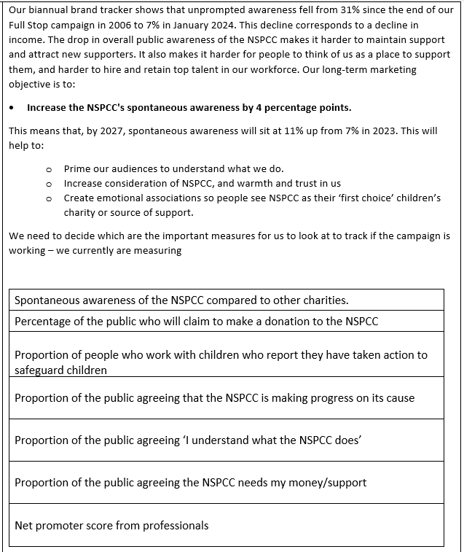

Appendix B: Survey Section 1
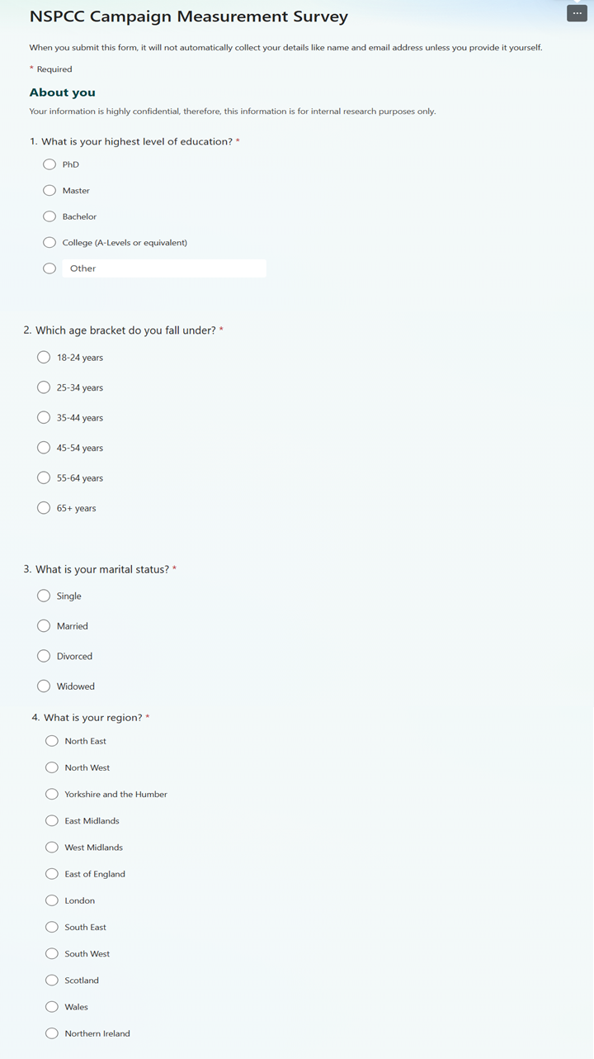

Appendix C: Survey Section 2 for Donors
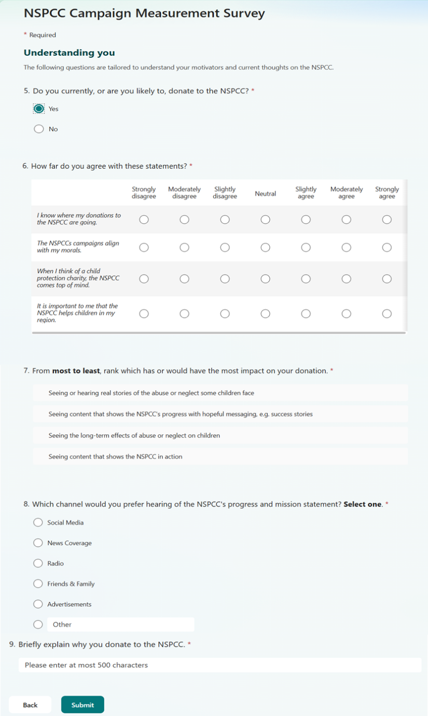

Appendix D: Survey Section 2 for Non-Donors
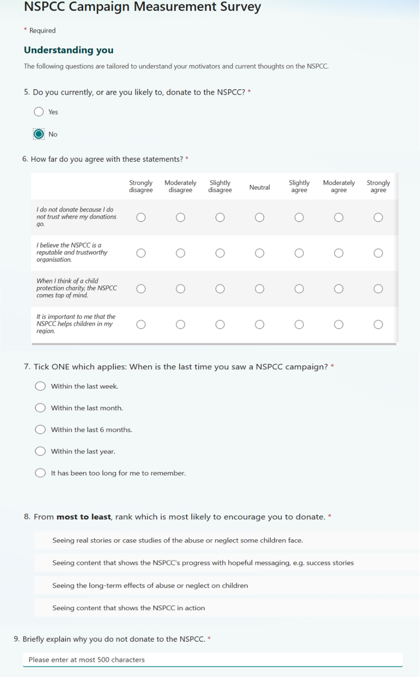

Appendix E: Link to Interactive Story
https://public.tableau.com/app/profile/ester.marku/viz/NSPCC_17540616127510/Story1

Reference List
Alba, J.W. and Hutchinson, J.W. (1987) 'Dimensions of consumer expertise', Journal of Consumer Research, pp.411-454.
Andreoni, J. (2006) 'Philanthropy', in S. Kolm and J.M. Ythier (eds.) Handbook of the Economics of Giving, Altruism and Reciprocity. North-Holland, pp.1201-1269.
BBC News (2024) 'Article title', Available at: https://www.bbc.co.uk/news/articles/c36wgr4d03ko [Accessed date needed].
Bekkers, R. and Wiepking, P. (2011) 'A literature review of empirical studies of philanthropy: Eight mechanisms that drive charitable giving', Nonprofit and Voluntary Sector Quarterly, 40(5), pp.924-973.
Bennett, R. (2003) 'Factors underlying the inclination to donate to particular types of charity', International Journal of Nonprofit and Voluntary Sector Marketing, 8(1), pp.12-29.
Bennett, R. and Savani, S. (2003) 'Predicting the accuracy of public perceptions of charity performance', Journal of Targeting, Measurement and Analysis for Marketing, 11, pp.326-342.
Bilgin, Y. and Kethüda, Ö. (2022) 'Charity social media marketing and its influence on charity brand image, brand trust, and donation intention', International Journal of Voluntary and Nonprofit Organizations, 33(1), pp.75-88.
Bourassa, M.A. and Stang, A.C. (2016) 'Knowledge is power: Why public knowledge matters to charities', International Journal of Nonprofit and Voluntary Sector Marketing, 21(1), pp.13-30.
Bulso, N., Marsili, M. and Roudi, Y. (2019) 'On the complexity of logistic regression models', Neural Computation, 31(8), pp.1592-1623. doi:10.1162/neco_a_01207.
Campos, L., Andion, C., Serva, M., Rossetto, A. and Assumpção, J. (2011) 'Performance evaluation in non-governmental organizations (NGOs): An analysis of evaluation models and their applications in Brazil', VOLUNTAS: International Journal of Voluntary and Nonprofit Organizations, 22, pp.238-258.
Cheung, C.K. and Chan, C.M. (2000) 'Social-cognitive factors of donating money to charity, with special attention to an international relief organization', Evaluation and Program Planning, 23(2), pp.241-253.
Coyle, J. and Williams, B. (2000) 'An exploration of the epistemological intricacies of using qualitative data to develop a quantitative measure of user views of health care', Journal of Advanced Nursing, 31, pp.1235-1243.
Durtina, R.E. (1984) 'Measurement preconditions for assessing nonprofit performance: An exploratory study', The Government Accountants Journal, 33(2), pp.13-19.
Ebrahim, A. (2005) 'Accountability myopia: Losing sight of organizational learning', Nonprofit and Voluntary Sector Quarterly, 34(1), pp.56-87.
Erlandsson, A., Björklund, F. and Bäckström, M. (2015) 'Emotional reactions, perceived impact and perceived responsibility mediate the identifiable victim effect, proportion dominance effect and in-group effect respectively', Organizational Behavior and Human Decision Processes, 127, pp.1-14.
Fazio, A., Reggiani, T. and Scervini, F. (2023) 'Social media charity campaigns and pro-social behaviour: Evidence from the Ice Bucket Challenge', Journal of Economic Psychology, 96, p.102624.
Gilroy, V., Martin, K., Stanley, K. and Radford, L. (2022) '"Campaigning for more responsive parenting": lessons learned from the NSPCC's Look, Say, Sing, Play campaign'. London: NSPCC.
Hamad, E.O., Savundranayagam, M.Y., Holmes, J.D., Kinsella, E.A. and Johnson, A.M. (2016) 'Toward a mixed-methods research approach to content analysis in the digital age: The combined content-analysis model and its applications to health care Twitter feeds', Journal of Medical Internet Research, 18(3), p.e60. doi:10.2196/jmir.5391.
Hurmerinta-Peltomäki, L. and Nummela, N. (2006) 'Mixed methods in international business research: A value-added perspective', Management International Review, 46, pp.439-459.
Hyndman, N. and McConville, D. (2018a) 'Making charity effectiveness transparent: Building a stakeholder-focussed framework of reporting', Financial Accountability & Management, 34(2), pp.133-147.
Hyndman, N. and McConville, D. (2018b) 'Trust and accountability in UK charities: Exploring the virtuous circle', The British Accounting Review, 50(2), pp.227-237.
Imed, N. and Zorgati, H. (2025) 'Impact of generational awareness of charity on attitudes to the homeless and donation intentions: Moderating role of religiosity', International Journal of Research. Available at: https://ijor.co.uk/ijor/article/view/8674/4626 [Accessed 13 June 2025].
Long, J.S. (1997) Regression Models for Categorical and Limited Dependent Variables. Sage Publications.
M·E·L Research (2021) NSPCC Professionals Brand Tracker. London: NSPCC.
Martínez-Plumed, F., Contreras-Ochando, L., Ferri, C., Hernandez-Orallo, J., Kull, M., Lachiche, N., Ramirez-Quintana, M.J. and Flach, P. (2019) 'CRISP-DM twenty years later: From data mining processes to data science trajectories', IEEE Transactions on Knowledge and Data Engineering, 33(8), pp.3048-3061. doi:10.1109/TKDE.2019.2962680.
McDougle, L. (2014) 'Understanding public awareness of nonprofit organizations: Exploring the awareness-confidence relationship', International Journal of Nonprofit and Voluntary Sector Marketing, 19(3), pp.187-199.
Michel, G. and Rieunier, S. (2012) 'Nonprofit brand image and typicality influences on charitable giving', Journal of Business Research, 65(5), pp.701-707.
Mitani, A.A., Espin-Garcia, O., Fernández, D. and Landsman, V. (2024). Applying survey weights to ordinal regression models for improved inference in outcome-dependent samples with ordinal outcomes. Statistical methods in medical research, [online] 33(11-12), pp.2007–2026. doi:https://doi.org/10.1177/09622802241282091.
Morse, J.M. and Chung, S.E. (2003) 'Toward holism: The significance of methodological pluralism', International Journal of Qualitative Methods, 2(3), pp.1-12.
NSPCC (2021) 'Our donors and major supporters', NSPCC. Available at: https://www.nspcc.org.uk/support-us/ways-to-give/become-major-donor/our-major-donors [Accessed 15 August 2025].
NSPCC (2025a) 'Organisation structure', NSPCC. Available at: https://www.nspcc.org.uk/about-us/organisation-structure/[Accessed date needed].
NSPCC (2025b) 'Ten-year strategy 2021-2031', NSPCC. Available at: https://www.nspcc.org.uk/about-us/performance-plans-strategy/ [Accessed 10 June 2025].
O'Cathain, A., Murphy, E. and Nicholl, J. (2007) 'Why, and how, mixed methods research is undertaken in health services research in England: A mixed methods study', BMC Health Services Research, 7, p.85.
Pharoah, C. and Tanner, S. (1997) 'Trends in charitable giving', Fiscal Studies, 18(4), pp.427-443.
Ritchie, W.J. and Kolodinsky, R.W. (2003) 'Nonprofit organization financial performance measurement: An evaluation of new and existing financial performance measures', Nonprofit Management and Leadership, 13(4), pp.367-381.
Schlegelmilch, B.B., Love, A. and Diamantopoulos, A. (1997) 'Responses to different charity appeals: The impact of donor characteristics on the amount of donations', European Journal of Marketing, 31(8), pp.548-560.
Sargeant, A. and Lee, S. (2004) 'Trust and relationship commitment in the United Kingdom voluntary sector: Determinants of donor behaviour', Psychology & Marketing, 21(8), pp.613-635.
Shumate, M., Pilny, A., Atouba, Y.C., Kim, J., Peña-y-Lillo, M., Cooper, K., Sahagun, A. and Yang, S. (2013) 'A taxonomy of communication networks', in Communication Yearbook 37. Routledge, pp.121-150.
Singh, P., Singh, N., Singh, K.K. and Singh, A. (2021) 'Diagnosing of disease using machine learning', in Machine Learning and the Internet of Medical Things in Healthcare. Academic Press, pp. 89-111. doi: 10.1016/B978-0-12-821229-5.00003-3.
Sisco, H. and McCorkindale, T. (2013) 'Communicating "pink": An analysis of the communication strategies, transparency, and credibility of breast cancer social media sites', International Journal of Nonprofit and Voluntary Sector Marketing, 18(4), pp.287-301.
Stanley, K. (2017) 'Evidence in action: Measuring NSPCC's impact', Research Live.
Stoilova, M., Livingstone, S. and Donovan, S. (2019) Outcomes and effectiveness of children's helplines: systematic evidence mapping. London: NSPCC.
Stoltzfus, J.C. (2011) 'Logistic regression: A brief primer', Academic Emergency Medicine, 18(10), pp.1099-1104.
Touré-Tillery, M. and Fishbach, A. (2017) 'Too far to help: The effect of perceived distance on the expected impact and likelihood of charitable action', Journal of Personality and Social Psychology, 112(6), p.860.
Venable, B.T., Rose, G.M., Bush, V.D. and Gilbert, F.W. (2005) 'The role of brand personality in charitable giving: An assessment and validation', Journal of the Academy of Marketing Science, 33(3), pp.295-312.
Vrigazova, B. (2021) 'The proportion for splitting data into training and test set for the bootstrap in classification problems', Business Systems Research: International Journal of the Society for Advancing Innovation and Research in Economy, 12(1), pp.228-242.
Webb, D.J., Green, C.L. and Brashear, T.G. (2000) 'Development and validation of scales to measure attitudes influencing monetary donations to charitable organizations', Journal of the Academy of Marketing Science, 28, pp.299-309.
Yang, Y., Brennan, I. and Wilkinson, M. (2014) 'Public trust and performance measurement in charitable organizations', International Journal of Productivity and Performance Management, 63(6), pp.779-796

https://intranet.birmingham.ac.uk/student/academic-support/academic-integrity-support-and-advice.aspx
https://intranet.birmingham.ac.uk/as/registry/legislation/codesofpractice/index.aspx
https://intranet.birmingham.ac.uk/as/libraryservices/asc/student-guidance-gai.aspx

